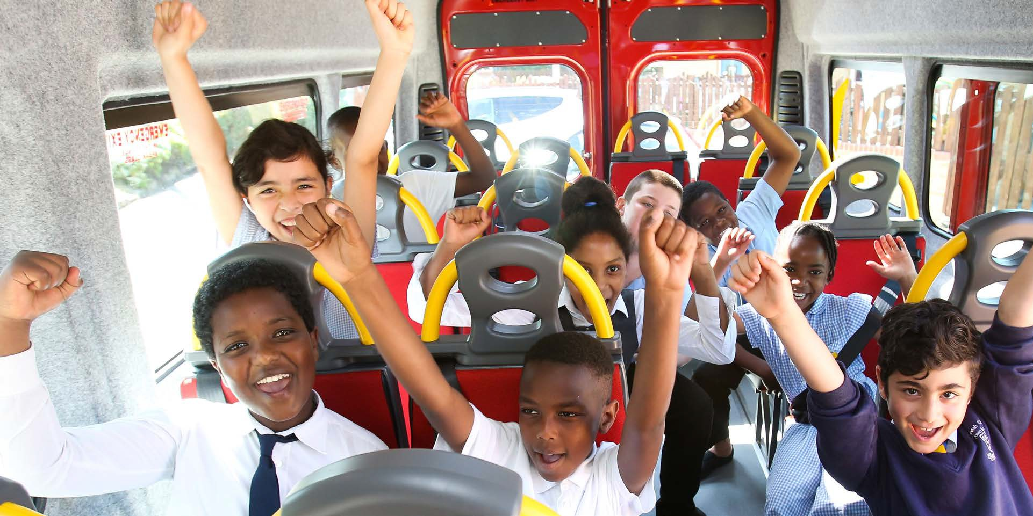


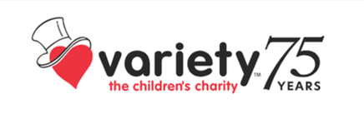

SUNSHINE COACH PROGRAMME
Guide 2025

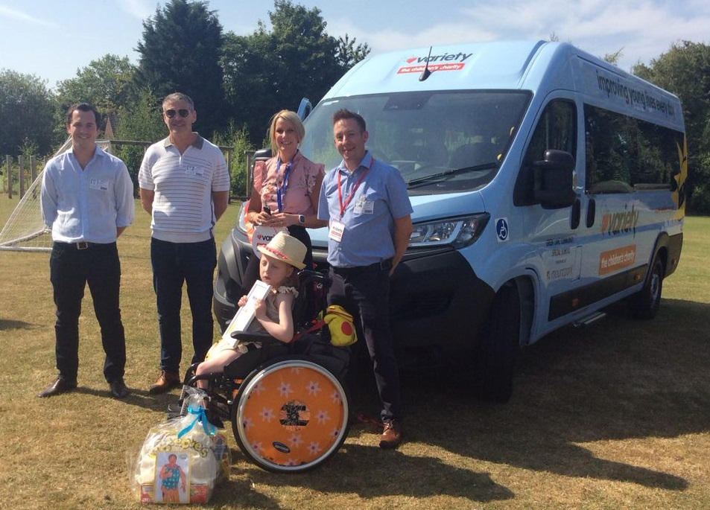
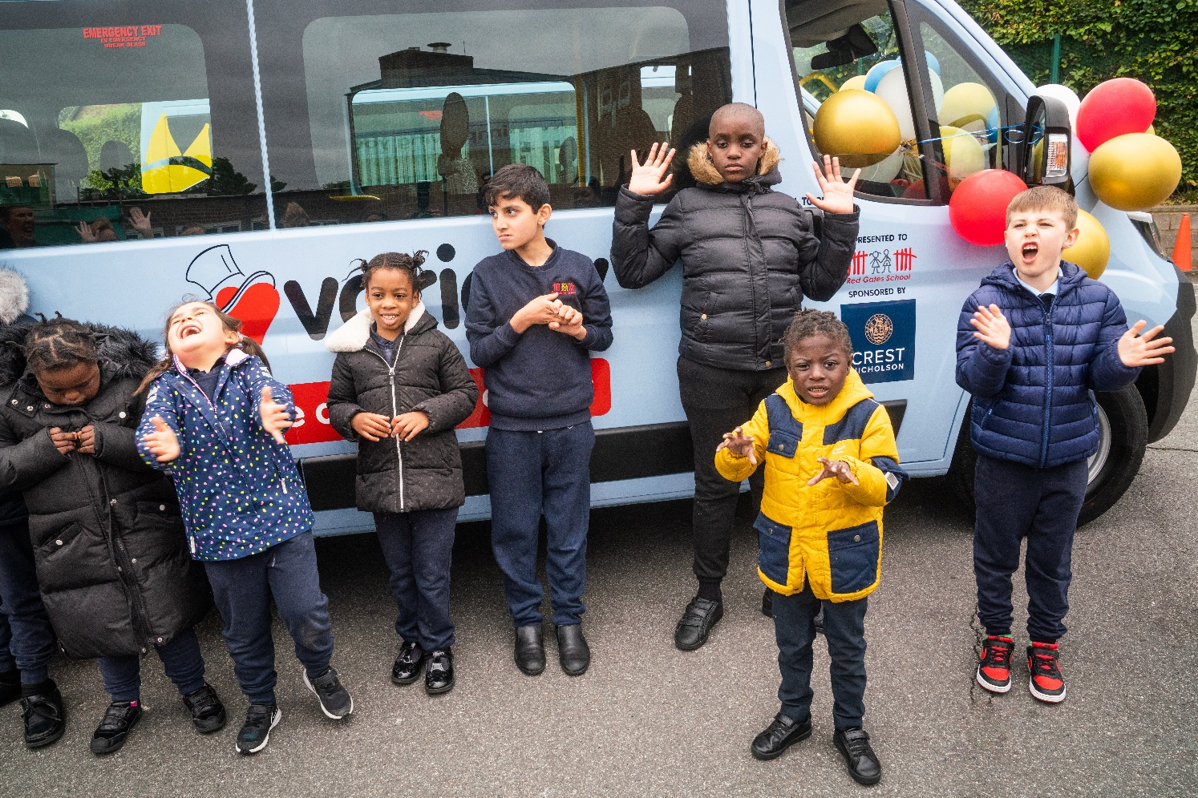

About Variety
Greenlane School receive a new Sunshine coach July 2022 with Variety Young Ambassador Hollie.

Red Gates pupils enjoying their new Sunshine Coach.

Sunshine Coaches

Variety have delivered over 5,900 coaches.

Since our first coach was donated to Queen Mary’s Children’s Hospital in 1962.
In the UK, there are more than 1.3 million disabled children and nearly 4 million children living in poverty. Variety, the Children’s Charity, exists to improve their lives. We believe that all children should have an equal opportunity to reach their potential, regardless of circumstances or disabilities.
We offer practical help that makes an immediate difference to children and young people under the age of 19. Our iconic Sunshine Coaches provide adapted, accessible transport for SEND schools and other non-profit organisations, enabling children to access opportunities and experiences that would otherwise be difficult to get to, such as getting around their local community, days out, trips to local attractions, and broader curriculum activities.
These all help to build the children’s skills, experiences, and confidence.

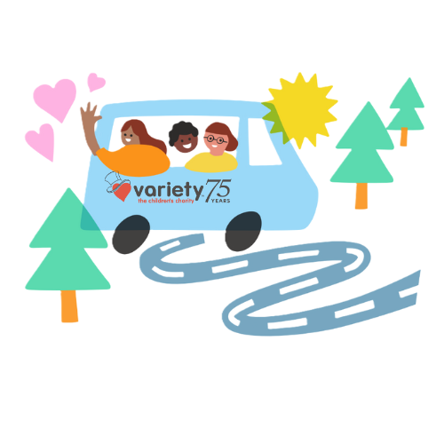
Our coaches change lives.

Variety, the Children’s Charity receives Sunshine Coach applications throughout the year. Each coach delivered results in a positive change for the applicant, resulting in many children benefiting from the addition of their new coach.
Variety Sunshine Coaches make it possible for children with additional needs, or who are growing up in economically deprived areas, to learn practical skills, gain access to sport and play facilities and enjoy trips out with their friends.

‘The new coach will allow the pupils to take part in activities in the community. Having a specialist coach for the pupils to travel in safety and comfort allows us to take learning beyond the school. ‘
Nicola Allan, Headteacher at Maes Ebbw School
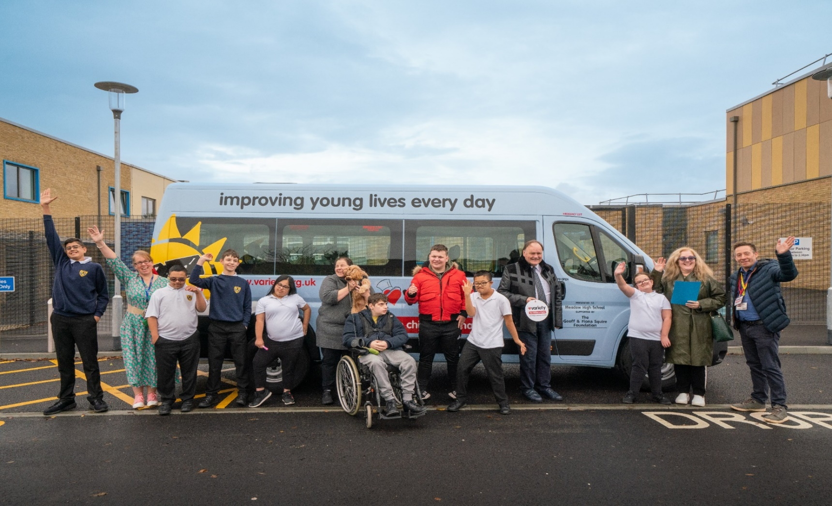
Meadow High receiving their new Sunshine Coach

Each year our coaches help thousands of children and young people across the UK

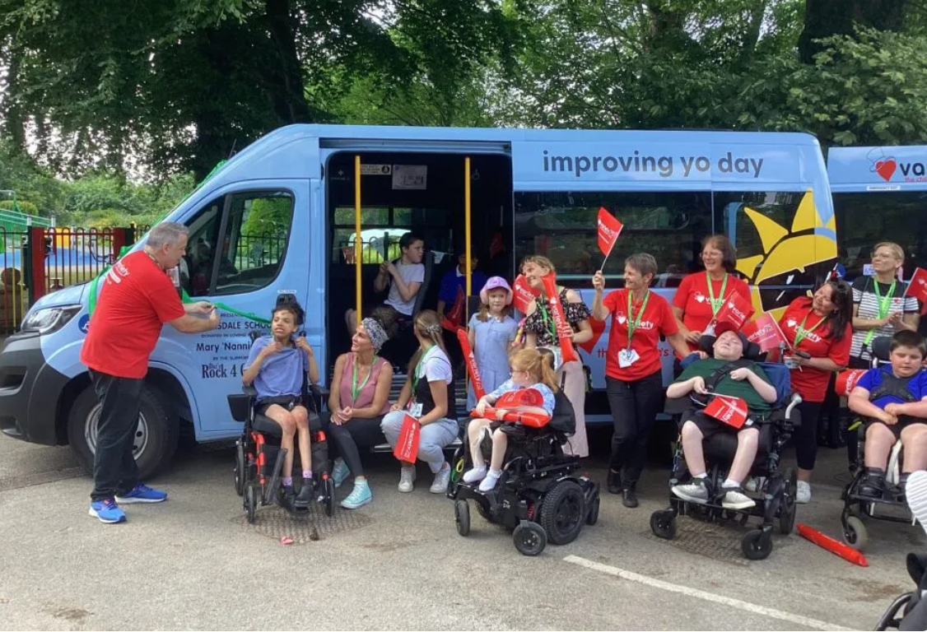
Approx 45% of all children helped are located in areas of deprivation.

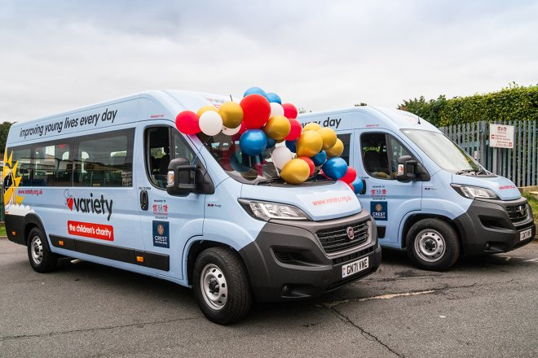

About Variety Programmes

We fund and deliver life-changing programmes that give children and young people across the UK
a better future.
Since we were founded in 1949, we’ve raised over £200 million and
supported more than 800,000 children who are disadvantaged or have disabilities
across the UK.
When statutory funding cannot adequately meet a child’s needs, Variety steps in.
We support children in four ways:


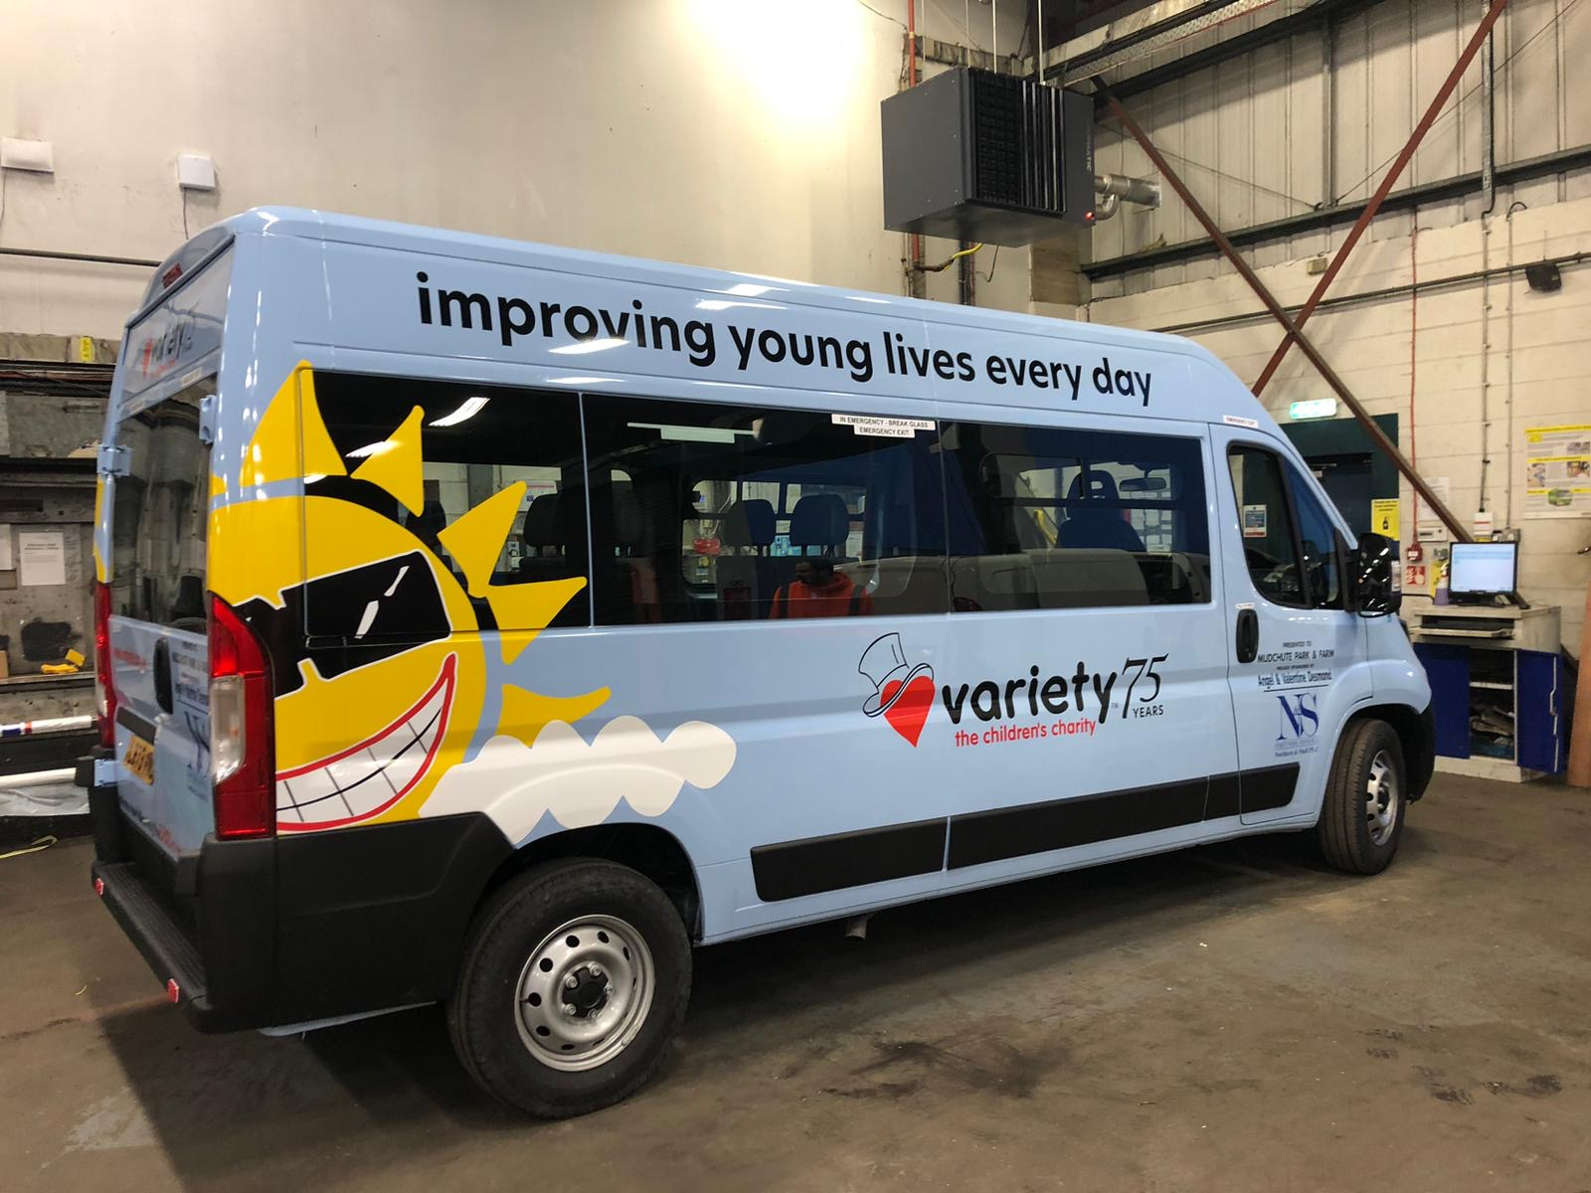
Education – our grants encourage learning, develop skills and boost confidence and mental health
Mobility – from funding wheelchairs to providing our famous Sunshine Coaches
Experiences – we love creating memories with our Great Days Out
Health – from providing specialist equipment to funding the Variety Children’s Hospital

Our work helps give children and young people greater wellbeing, independence, social inclusion,
mobility and self-esteem and allow them to live their best lives – no matter who they are.

Sunshine Coaches are recognisable and change the lives for many children across the UK.
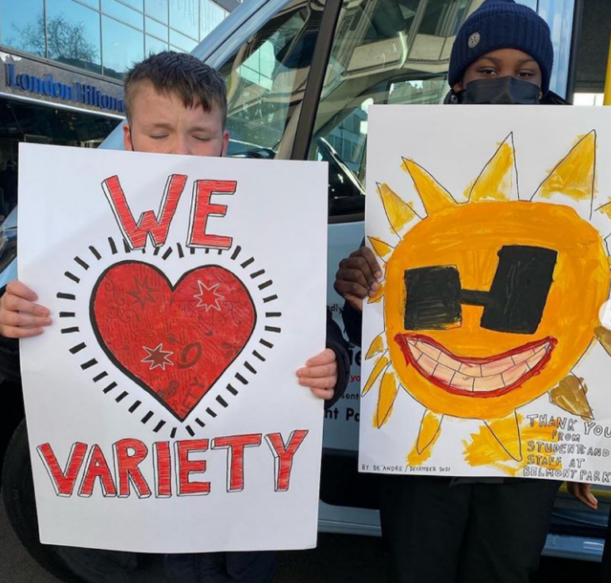

Get in touch.
For more information about our Sunshine Coaches, please call 020 7428 8100 or email coaches@variety.org.uk

Are you looking to apply for a Sunshine Coach?
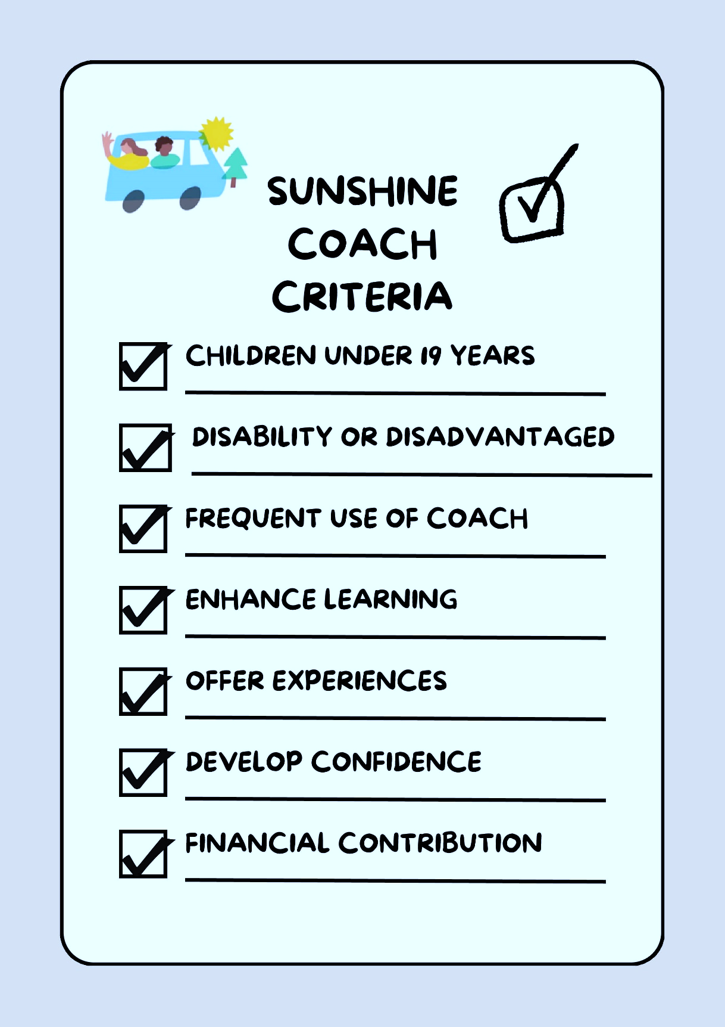
If you are thinking about applying for a new Sunshine Coach, here is the key information you will need to know:

Sunshine Coach Eligibility Criteria
- Sunshine Coaches are for organisations, schools, childcare settings, hospices, youth clubs, whereby the children attending are under the age of 19 years that cater for those children/young people with disabilities or who are significantly disadvantaged.
- The Sunshine Coach must be used frequently, at least 4 times per week, the coach should not be used just as a taxi service, instead its use is to offer new opportunities, experiences, learning and broaden the curriculum offer to outside the classroom.
- We ask applicants to complete the application form with as much detail as possible.
- We ask applicants to have a financial contribution towards their coach (this is 35% of the cost of the vehicle, sponsorship will fund the remaining 65%. (Amounts are dependent on type of coach and highlighted on our application form).
- We ask applicants to be patient as the process from applying to receiving a coach can take between 6 months and 1 year. (In some cases this can be longer).
- We ask applicants to be mindful about their VAT status, as VAT is charged on the total vehicle price and will be the responsibility of the beneficiary to pay. If you qualify for VAT relief you can claim this back, if you are VAT exempt we ask that you provide evidence, if you pay VAT you will be expected to do so direct to our coach supplier.
We currently offer the following coach types:
14 seater
13 seater with tail lift
17 seater
17 seater with tail lift

The Process (this process can take between 6 - 12 months to complete)
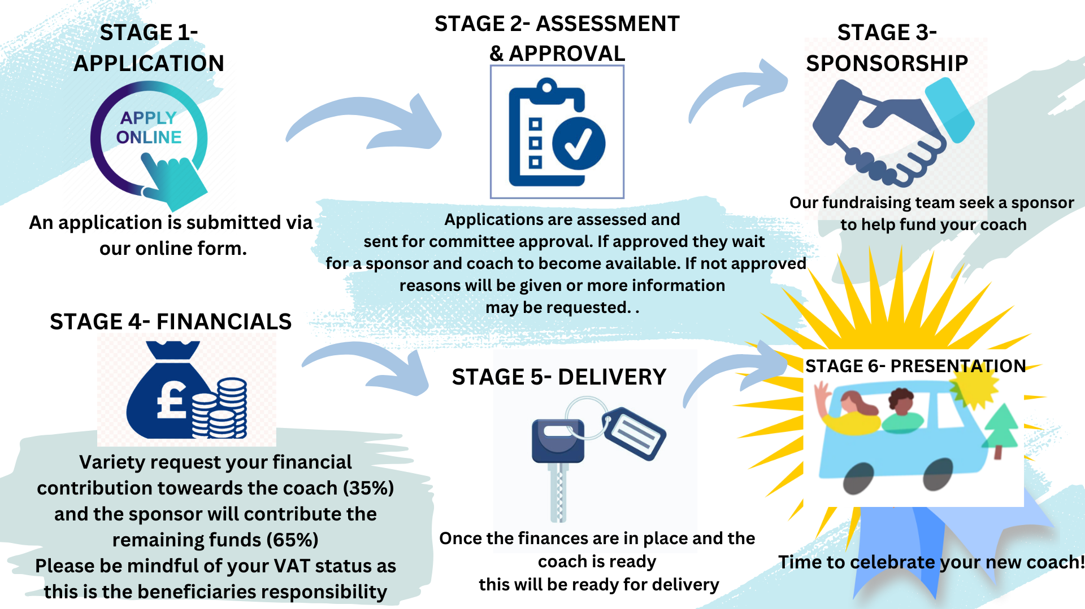

Some of our valued sponsors

We are extremely proud and grateful to work with companies, Trusts, Foundations, and individual donors who believe in our mission.
Their support has helped give thousands of children the opportunity to reach their potential and truly make the most of their childhoods.

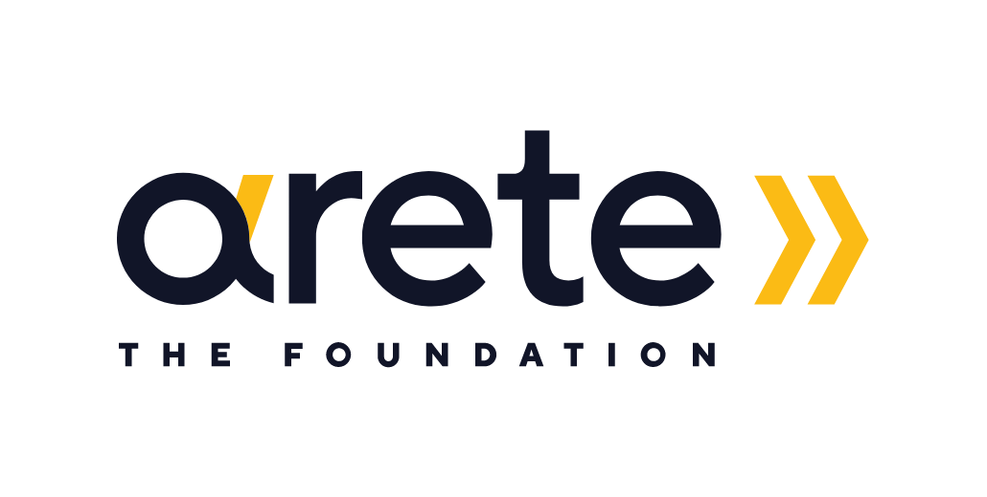







Variety Golf



Cineworld



St James’s Place

Michael Josephson

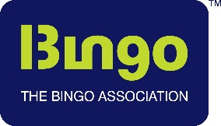

Bingo Association



DPD

Mountpark Caring Family Foundation

DPD CEO, Elaine Kerr, donates a Sunshine Coach to Oliver Flowers, Headteacher at The Westminster School, West Midlands
Joie Baby Arete Foundation


Variety have delivered over 550 coaches in the past 10 years to deserving schools, organisations, and hospices.
We delivered an amazing 87 Sunshine coaches to beneficiairies across the UK in 2024.

"I really hope the bright new Sunshine Coach will broaden horizons for all the children at Forest School and give them the freedom and opportunity to experience many wonderful educational and recreational days out." Lea Ziff (Sponsor)

Paul James, co-headteacher at The Forest School, said: "We are extremely grateful to our sponsor and Variety, the Children's Charity for providing a new Sunshine Coach.’’

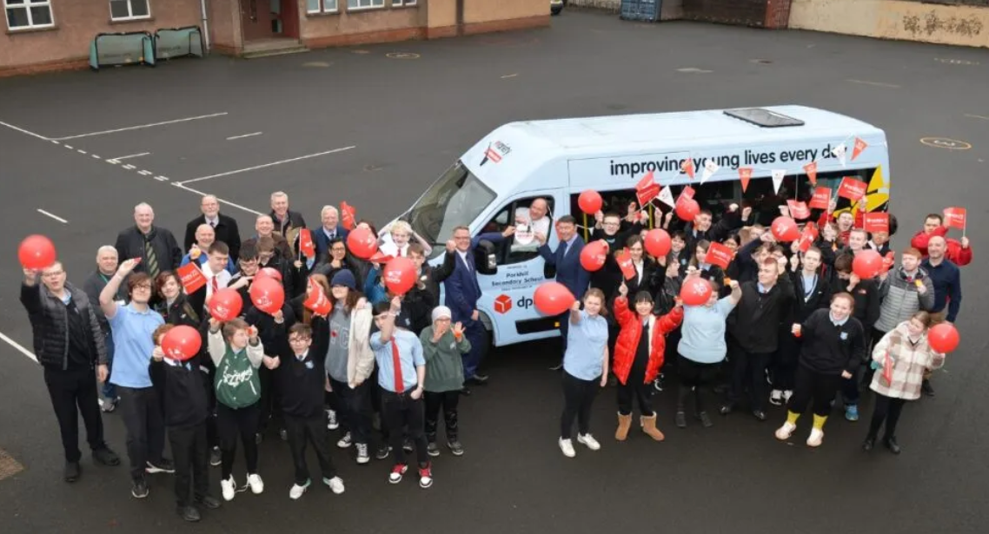
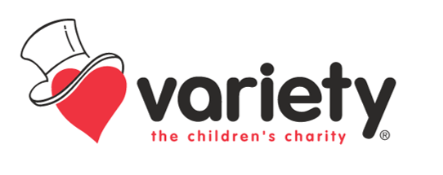
www.variety.org.uk

