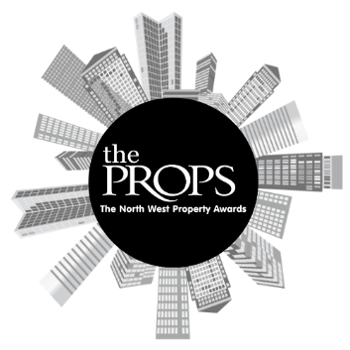

The North West Props Awards 2025
Nomination Form

Award Category: Property Deal of the Year
This category seeks to reward those who have pulled off the most notable property deal of the year in the North West. This could relate to a sale, letting, investment acquisition or lease re-gear.
Criteria:
Open to developers, agents, investors and/or funders.
Recognising a property deal that stood out, whether in terms of innovation, uniqueness and/or strong financial rewards. The emphasis is on quality, not necessarily scale. Both corporate level and property level deals are eligible.
Deal should have exchanged and/or completed between 1st October 2024 and 30th September 2025.
Please submit this form and any supporting evidence to sally.richards@variety.org.uk.
Property / Project Name:
Project stakeholders (award nominees):
Contact Name:
Contact Email Address:
Contact Phone Number:
Overview of the Project:

Reason for nomination:

Anything else you would like to add:
Nominator contact details (if different from above). Please include, Name, phone number and email:
Supporting Documents attached:

